





[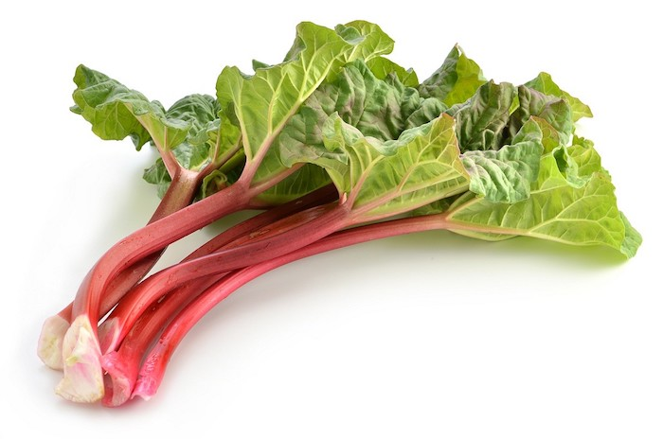](https://www.google.dk/url?sa=i&url=https%3A%2F%2Fkissmychef.com%2Fchaud-devant%2Floeuf-ou-la-poule-chaud-devant%2Fmatieres_premieres%2Frhubarbe-tatie-danielle-potager&psig=AOvVaw1czLoR1CoAU8UsT_u8D0l9&ust=1587020635490000&source=images&cd=vfe&ved=0CAIQjRxqFwoTCNCZtuHu6egCFQAAAAAdAAAAABAI)















C:\Program Files (x86)\Picto Selector\png\Mulberry Symbol Set\thunder storm.wmf



C:\Program Files (x86)\Picto Selector\png\Mulberry Symbol Set\thunder storm.wmf







C:\Program Files (x86)\Picto Selector\png\Mulberry Symbol Set\good.wmf