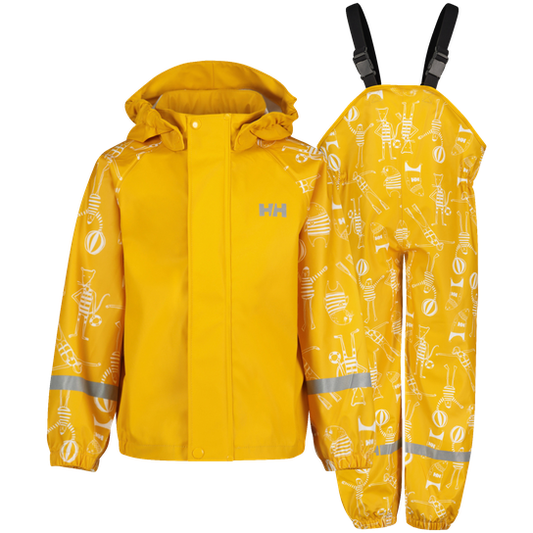

[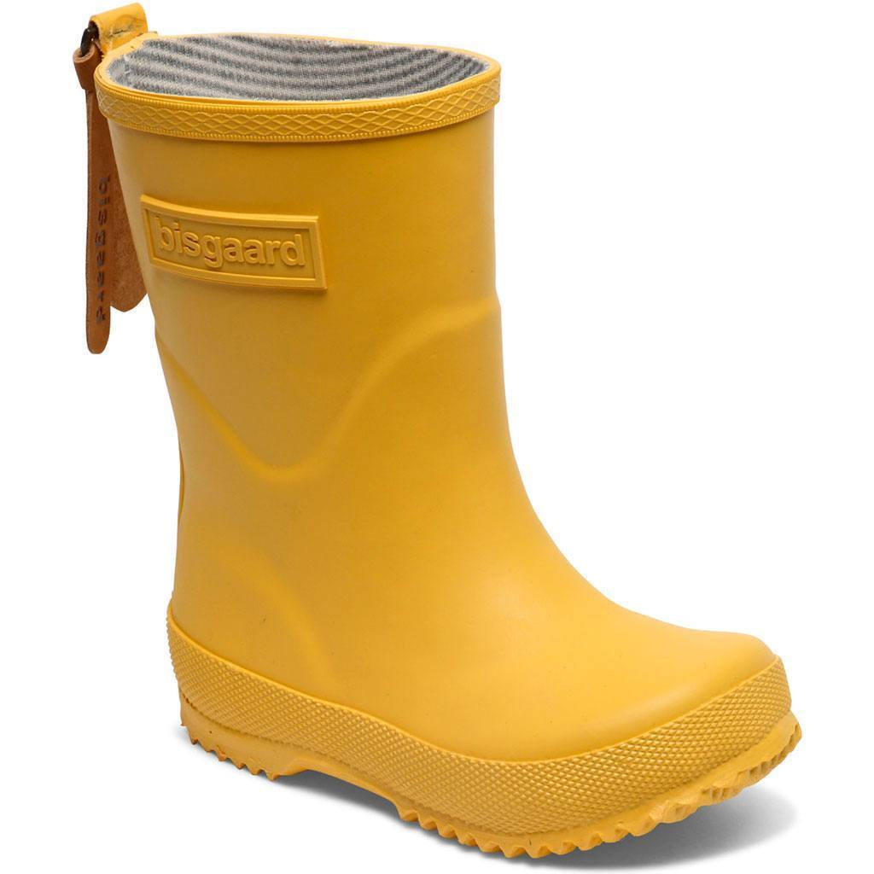](https://www.google.com/url?sa=i&url=https%3A%2F%2Fwww.mollyogmy.dk%2Fproducts%2Fbisgaard-gummistovle-gul&psig=AOvVaw3n1MdmLwo9lsHeWNODXufs&ust=1584789779010000&source=images&cd=vfe&ved=0CAIQjRxqFwoTCLCC_pD4qOgCFQAAAAAdAAAAABAb)

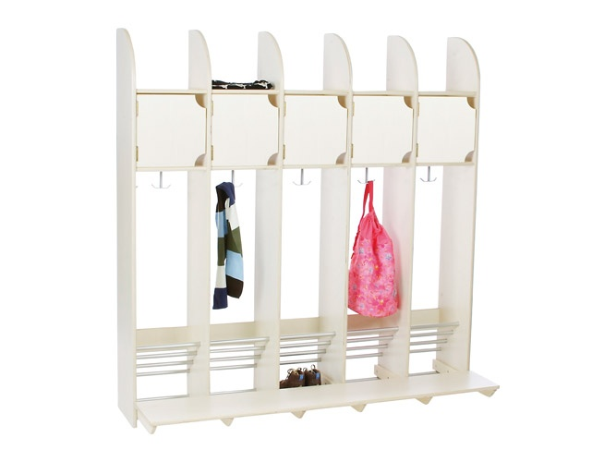

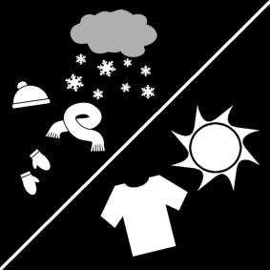

[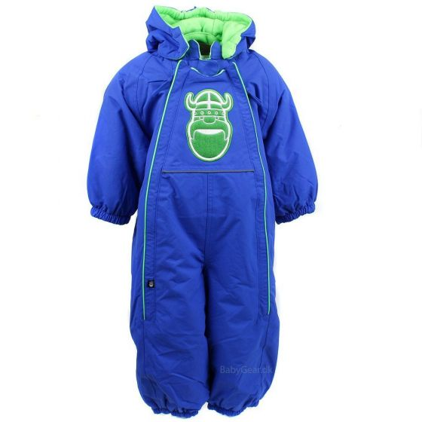](https://www.google.com/url?sa=i&url=https%3A%2F%2Fwww.babygear.dk%2Fflyverdragt-fra-danefae-intense-blue-viking.html&psig=AOvVaw2LtT3b92GDesvY-FJcvwMt&ust=1584789904557000&source=images&cd=vfe&ved=0CAIQjRxqFwoTCIj2hs34qOgCFQAAAAAdAAAAABAW)

[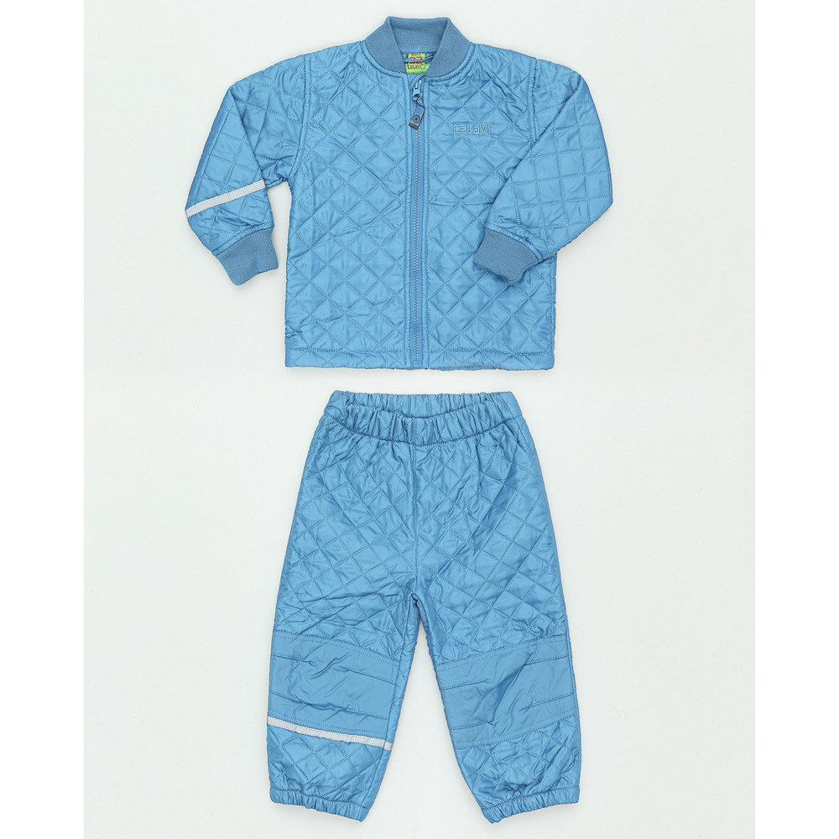](https://www.google.com/url?sa=i&url=https%3A%2F%2Fmodejagten.dk%2Fshop-celavi-termotoj-celavi-termotoj-i-bla-til-born-pa-miinto-dk%2F&psig=AOvVaw0R_sZHhUp-BcK7_tT3Kjme&ust=1584790787760000&source=images&cd=vfe&ved=0CAIQjRxqFwoTCKjO5_H7qOgCFQAAAAAdAAAAABAF)

[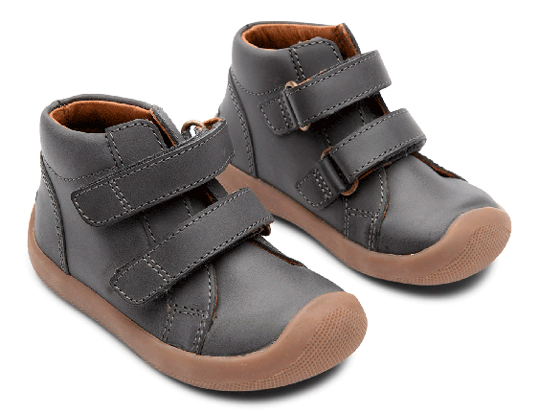](https://www.google.com/url?sa=i&url=https%3A%2F%2Fwww.eventyrsport.dk%2Fthe-walker-velcro-0421900340.html&psig=AOvVaw24u72DYFadOZxNQ3aC2nOI&ust=1584790168124000&source=images&cd=vfe&ved=0CAIQjRxqFwoTCJjLz835qOgCFQAAAAAdAAAAABAD)

[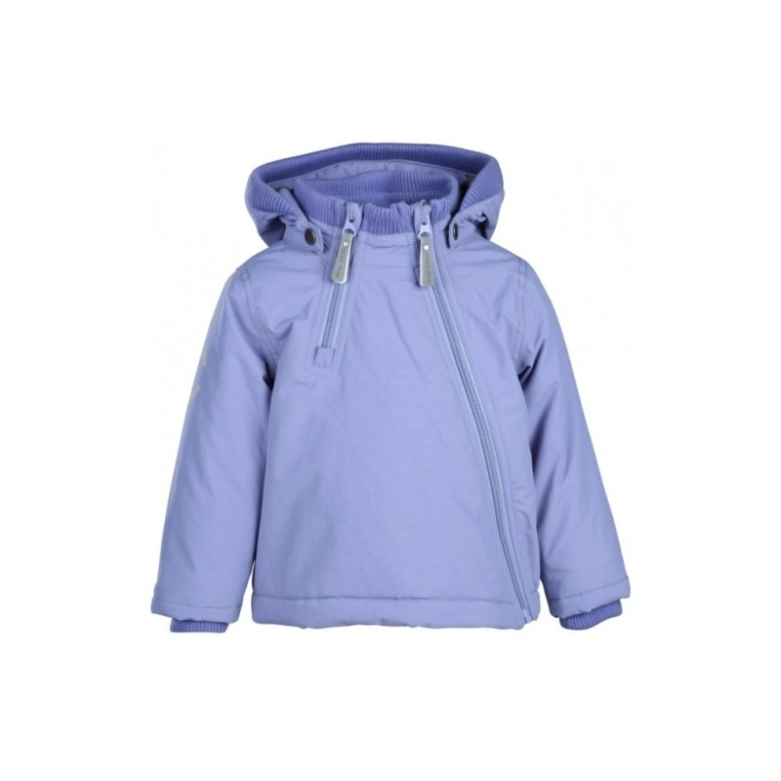](https://www.google.com/url?sa=i&url=https%3A%2F%2Fwww.heaven4kids.dk%2FMikk-Line-vinterjakke-152005309&psig=AOvVaw1NpZS7dUxl0Hi3ZxQNkhY-&ust=1584790570676000&source=images&cd=vfe&ved=0CAIQjRxqFwoTCLj1sor7qOgCFQAAAAAdAAAAABAc)

[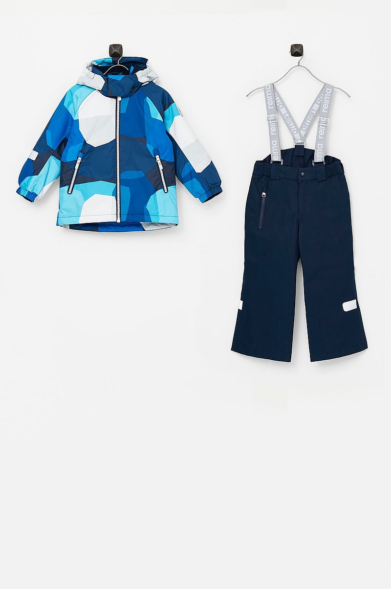](https://www.google.com/url?sa=i&url=https%3A%2F%2Fwww.ellos.dk%2Freima%2Fskisaet-hamara%2F1563472-02&psig=AOvVaw1lL54u2a90a6AqN9NZ0_XR&ust=1584790671609000&source=images&cd=vfe&ved=0CAIQjRxqFwoTCOiOvLr7qOgCFQAAAAAdAAAAABAL)

[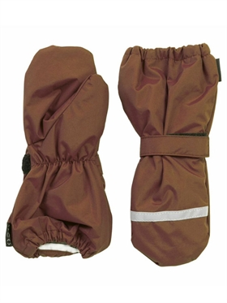](https://www.google.com/url?sa=i&url=https%3A%2F%2Fwww.termoland.dk%2Fshop%2Fluffer-i-nylon-4148p.html&psig=AOvVaw2DCKqEROVfD6XYYNu1X9v0&ust=1587030065227000&source=images&cd=vfe&ved=0CAIQjRxqFwoTCKjZzuyR6ugCFQAAAAAdAAAAABAF)

[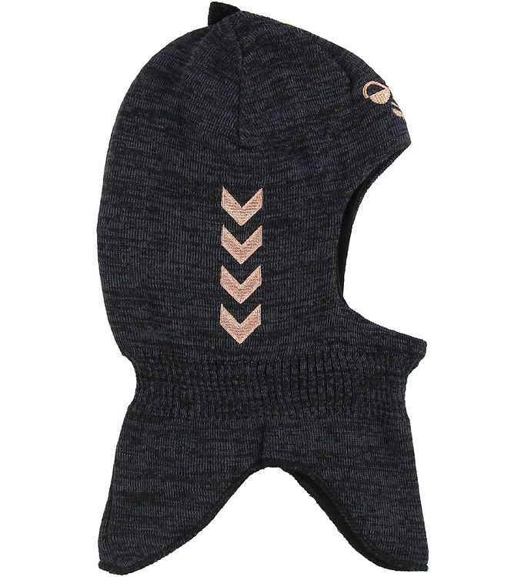](https://www.google.com/url?sa=i&url=https%3A%2F%2Fbabyhelp.dk%2Fvare%2Fhummel-elefanthue-uld-bomuld-2-lags-heat-graa-kobber-m-v%2F&psig=AOvVaw2B0Hkkfp1ULCrVPFoLCGDf&ust=1584790025426000&source=images&cd=vfe&ved=0CAIQjRxqFwoTCIDZqIb5qOgCFQAAAAAdAAAAABAW)

[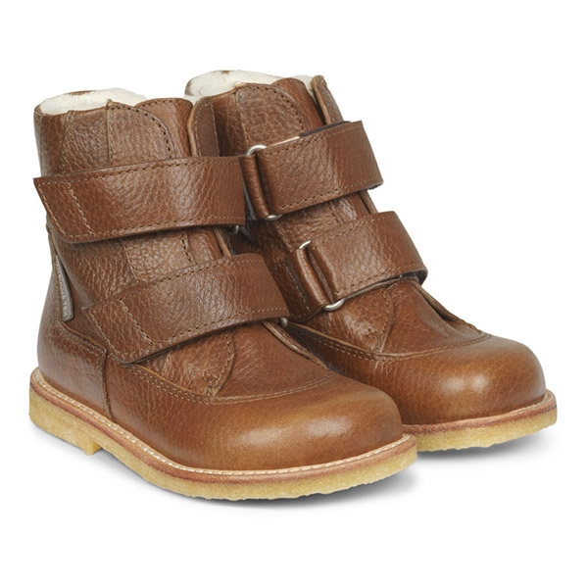](https://www.google.com/url?sa=i&url=https%3A%2F%2Fwww.parcellet.dk%2Fshop%2Fangulus-tex-vinterstoevler-cognac-37914p.html&psig=AOvVaw0WaG8mtM80iwZMdnSr8cxo&ust=1584790210571000&source=images&cd=vfe&ved=0CAIQjRxqFwoTCODP5t75qOgCFQAAAAAdAAAAABAE)

[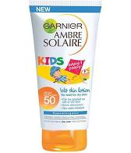](https://www.google.com/aclk?sa=l&ai=DChcSEwjE6fiGr7PoAhVL2t4KHdTDDVgYABAKGgJ3Yg&sig=AOD64_20YqDEId2awObGW6-y-DoqW4IVBg&adurl&ctype=5&ved=2ahUKEwinhu2Gr7PoAhWVgqQKHQhxB_4Qvhd6BAgBEEI)

[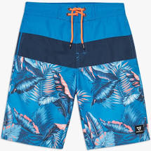](https://www.google.com/aclk?sa=l&ai=DChcSEwiAo_6trrPoAhVEzBgKHbCIAdgYABAGGgJsZQ&sig=AOD64_2D7DI8TRH2qCYFK9nEWueoDXXSdw&adurl&ctype=5&ved=2ahUKEwjr3fKtrrPoAhVByKQKHVz9Bq0Qvhd6BAgBEC4)[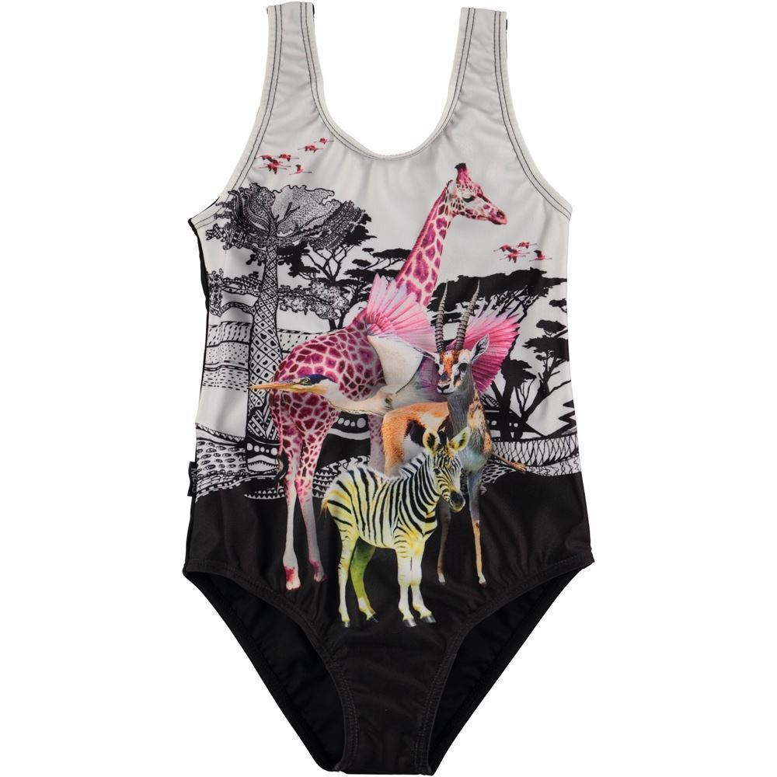](https://www.google.com/url?sa=i&url=https%3A%2F%2Fmillepercille.dk%2Fshop%2Fmolo-badedragt-nika-83637p.html&psig=AOvVaw0NwIx8O5rl1aEI_k61DwcO&ust=1585147964455000&source=images&cd=vfe&ved=0CAIQjRxqFwoTCLDk-ryus-gCFQAAAAAdAAAAABAE)

[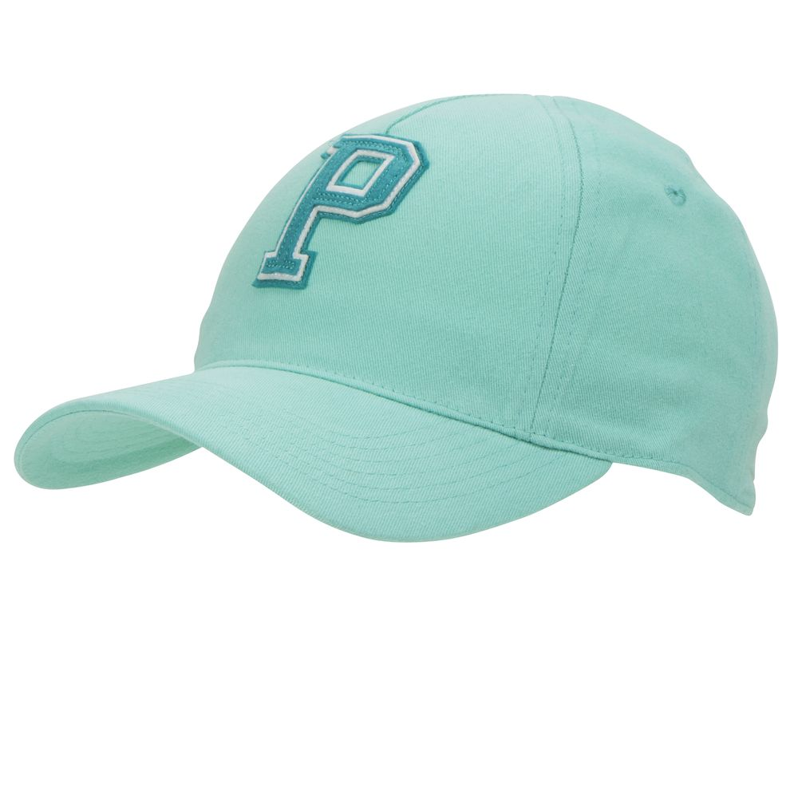](https://www.google.com/url?sa=i&url=https%3A%2F%2Fwww.polarnopyret.co.uk%2Fturquoise-kids-baseball-cap-60301868-522-5&psig=AOvVaw0fOyIwACbum9a1OEdFWH5h&ust=1585148024803000&source=images&cd=vfe&ved=0CAIQjRxqFwoTCJDY8Nmus-gCFQAAAAAdAAAAABAK)[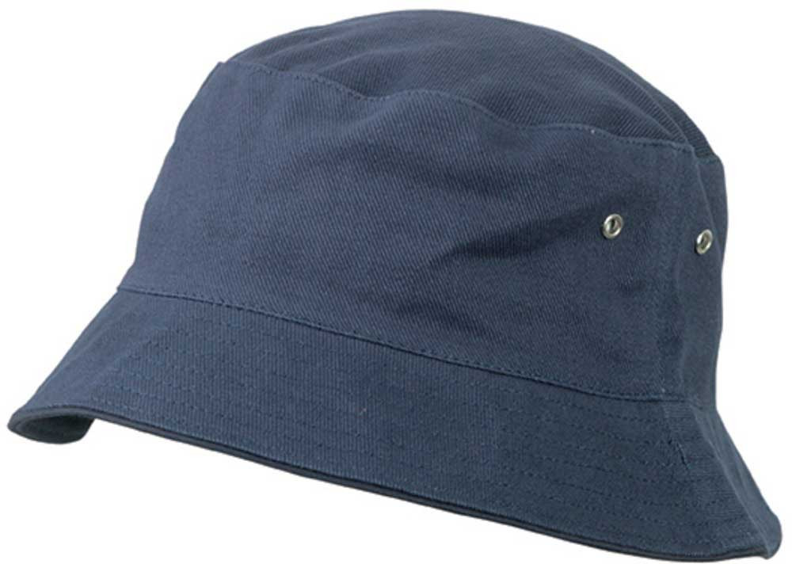](https://www.google.com/url?sa=i&url=https%3A%2F%2Fwww.t-shirtshop.dk%2Fbollehat-navy-born.html&psig=AOvVaw0YktoxKUnPw62faf_Ou9zV&ust=1585148059295000&source=images&cd=vfe&ved=0CAIQjRxqFwoTCIjEjequs-gCFQAAAAAdAAAAABAF)

[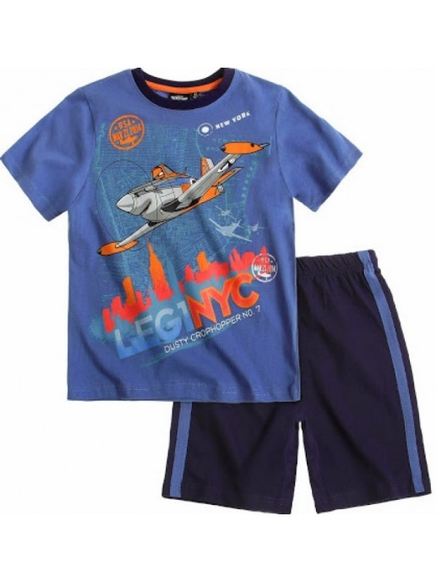](https://www.google.dk/url?sa=i&url=https%3A%2F%2Fwww.thefairytalecompany.dk%2Fplanes-shortssaet-sommerpyjamas-bla-bla.html&psig=AOvVaw0Kat5foKkxf-EU1pQS9UjH&ust=1584700479830000&source=images&cd=vfe&ved=0CAIQjRxqFwoTCPje-rurpugCFQAAAAAdAAAAABAF)

[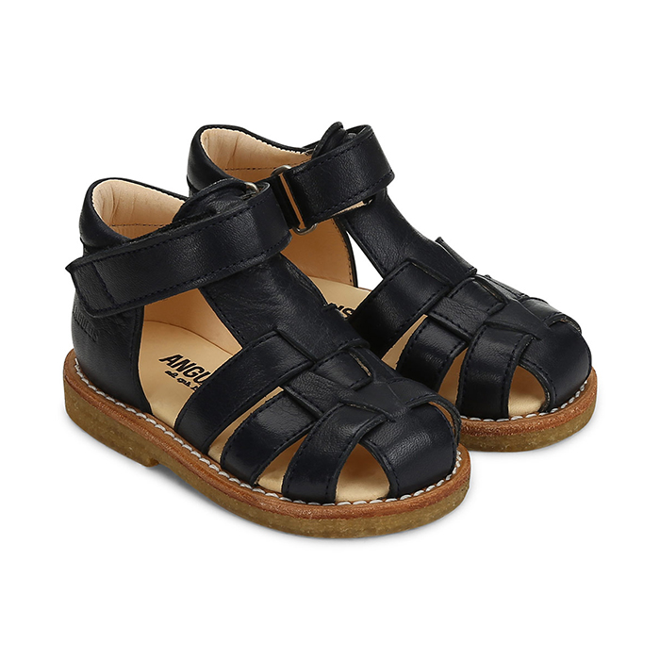](https://www.google.com/url?sa=i&url=https%3A%2F%2Fwww.astaogalfred.dk%2Fprodukt%2Fangulus-begyndersandal-flet-sort%2F&psig=AOvVaw1QjPogDx7WlL-CvAJJDKXh&ust=1584793550811000&source=images&cd=vfe&ved=0CAIQjRxqFwoTCPCmx5eGqegCFQAAAAAdAAAAABAf)

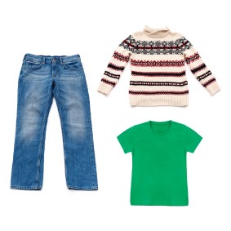

[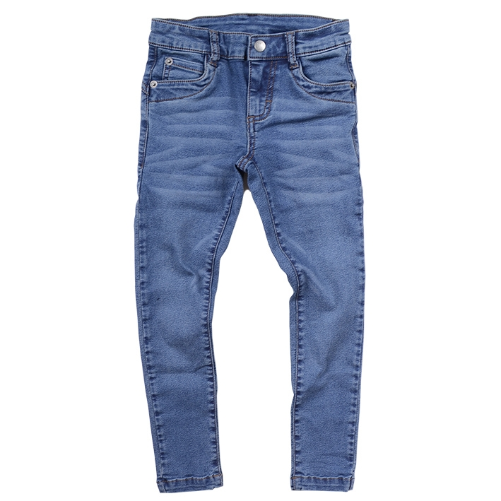](https://www.google.com/url?sa=i&url=https%3A%2F%2Fwww.krymmel.com%2Fshop%2Fdean-jeans-blue-12029p.html&psig=AOvVaw06--RALhM7mBa-SzxLvjws&ust=1584794903973000&source=images&cd=vfe&ved=0CAIQjRxqFwoTCLj75JyLqegCFQAAAAAdAAAAABAE)

[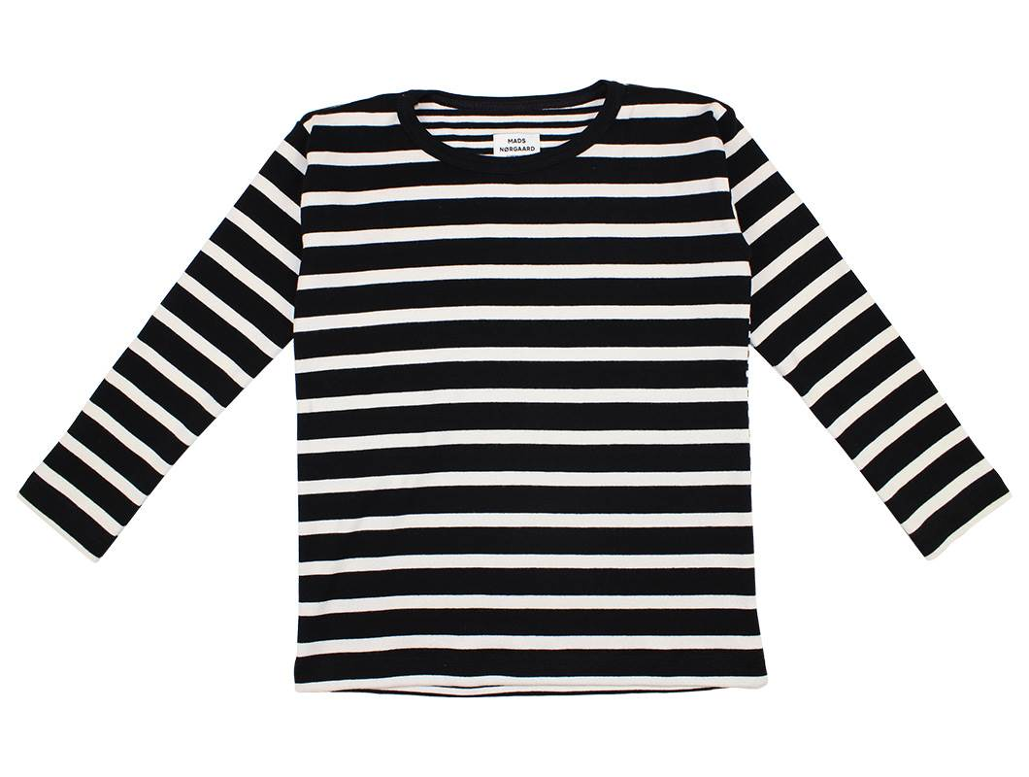](https://www.google.com/url?sa=i&url=https%3A%2F%2Fwww.milkywalk.dk%2Fshop%2Fmads-noergaard-bluse-28014p.html&psig=AOvVaw3q1_2QkRWk_W9SLgcuEcw_&ust=1584794757408000&source=images&cd=vfe&ved=0CAIQjRxqFwoTCND45NaKqegCFQAAAAAdAAAAABAG)

[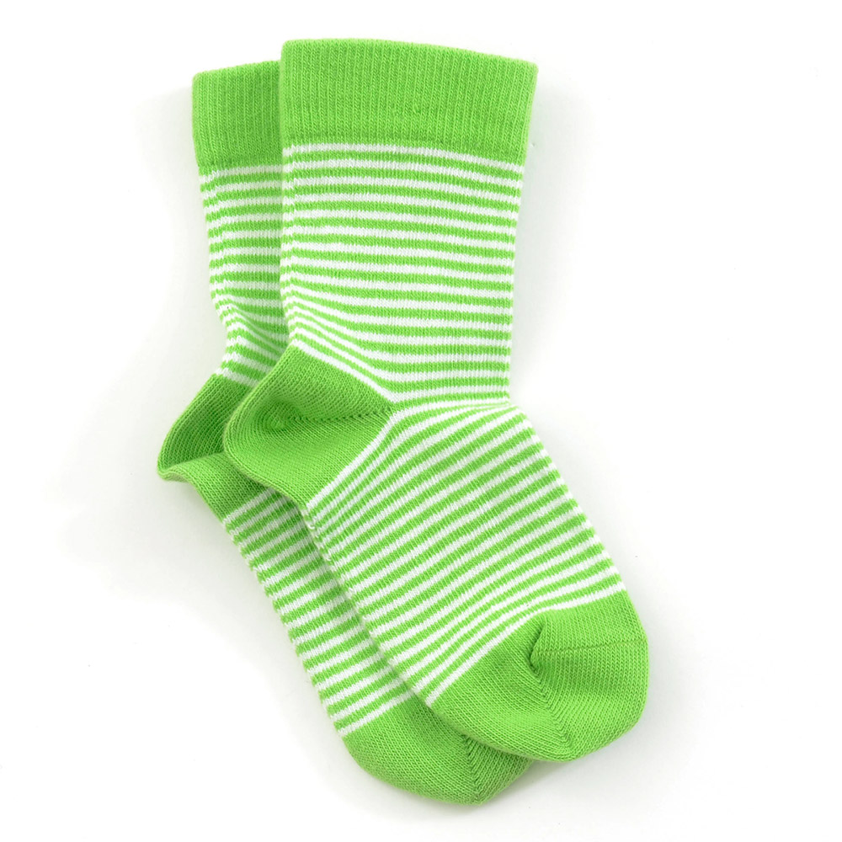](https://www.google.com/url?sa=i&url=https%3A%2F%2Fwww.thissocks.dk%2Fblog%2Fwiki-post%2Fmit-barn-vil-ikke-have-stroemper-paa-hjaelp%2F&psig=AOvVaw321GsDmWtvnPkJl3gE5oAC&ust=1584794798081000&source=images&cd=vfe&ved=0CAIQjRxqFwoTCODwm-qKqegCFQAAAAAdAAAAABAF)

[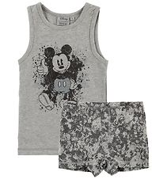](https://www.google.com/url?sa=i&url=https%3A%2F%2Fwww.kids-world.dk%2Fwheat-disney-undertoej-c-210_6914.html&psig=AOvVaw0e32BxNDu3DM7IB4orGUiq&ust=1584794687023000&source=images&cd=vfe&ved=0CAIQjRxqFwoTCKCYnLWKqegCFQAAAAAdAAAAABAE)

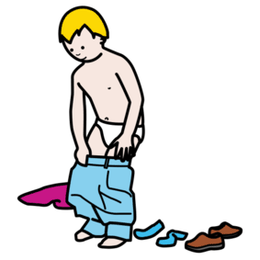

[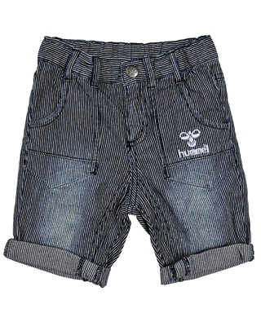](https://www.google.com/url?sa=i&url=http%3A%2F%2Fcheapkids.dk%2Fbillige-bukser-til-born%2Fbillige-shorts-til-born-og-billige-knickers%2F&psig=AOvVaw3-4GvPDOGzOXrFxlbH5RTW&ust=1584794951104000&source=images&cd=vfe&ved=0CAIQjRxqFwoTCIDkn7OLqegCFQAAAAAdAAAAABAW)