



















[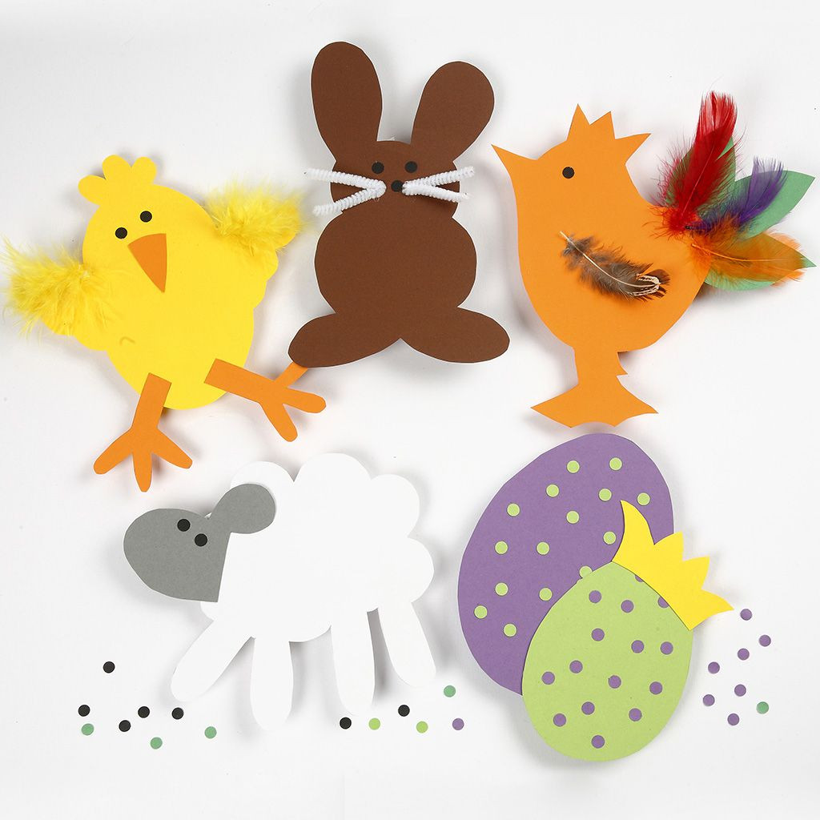](https://www.google.com/url?sa=i&url=https%3A%2F%2Fwww.cchobby.dk%2Fskabeloner-til-paskeklip-i-karton-i&psig=AOvVaw2mmMoSsW3WIgpdlFhgQu1W&ust=1584790907968000&source=images&cd=vfe&ved=0CAIQjRxqFwoTCMi6r7P8qOgCFQAAAAAdAAAAABAT)

[](https://www.google.dk/url?sa=i&url=https%3A%2F%2Fwww.danmarksflora.dk%2F0302.php%3Fplanteid%3D499%26side%3D3&psig=AOvVaw0KzSXB46RnT_dErfCY7YlU&ust=1584782604770000&source=images&cd=vfe&ved=0CAIQjRxqFwoTCOjxtbjdqOgCFQAAAAAdAAAAABAI)

C:\Program Files (x86)\Picto Selector\png\Mulberry Symbol Set\Harvest Festival.wmf

















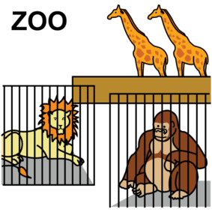







Happy Eid



Happy Ramadan

[](https://www.shutterstock.com/da/image-vector/ramadan-greeting-card-cute-cartoon-muslim-1065053006)

[](https://www.google.com/url?sa=i&url=https%3A%2F%2Fpixabay.com%2Fda%2Fimages%2Fsearch%2Flanterne%2520festival%2F&psig=AOvVaw1oA3E7zJCQ7tGe2dD6ohXc&ust=1585128553377000&source=images&cd=vfe&ved=0CAIQjRxqFwoTCLCO6pvmsugCFQAAAAAdAAAAABBM)











[](https://www.google.dk/imgres?imgurl=https%3A%2F%2Fmaritvold.no%2Fwp-content%2Fuploads%2F2014%2F12%2Flucia.jpg&imgrefurl=https%3A%2F%2Fmaritvold.no%2Fukesplan%2Fuke-50-1etg-2014%2Flucia%2F&tbnid=94zawvI4aBC2ZM&vet=12ahUKEwiiz_KqybLoAhWDD-wKHVLHCEcQMygUegQIARAw..i&docid=k0dvs4IyM-ZMIM&w=174&h=240&q=lucia%20optog%20tegning&ved=2ahUKEwiiz_KqybLoAhWDD-wKHVLHCEcQMygUegQIARAw)



